
DIGITAL IMAGE PROCESSING LAB
LAB REPORT 12

SUBMITTED BY:
Fahad khan : 23-SE-64

SUBMITTED TO:
ENGR. NAZIA BIBI

DEPARTMENT OF SOFTWARE ENGINEERING.
UNIVERSITY OF ENGINEERING AND TECHNOLOGY TAXILA.
LAB EXERCISE :
PYTHON CODE :
import tkinter as tk
from tkinter import filedialog # For file open/save dialogs
from PIL import Image, ImageTk # For converting images to a Tkinter-compatible format
import cv2 # OpenCV for image processing
import numpy as np # NumPy for array manipulations (optional here)

# Global variables to hold the current and processed image
current_image = None # Holds the original image
processed_image = None # Holds the processed version of the image

# Function to open and load an image from the file system
def open_image():
global current_image, processed_image
file_path = filedialog.askopenfilename() # Open file dialog
if file_path: # If a file is selected
current_image = cv2.imread(file_path) # Read the image using OpenCV (BGR format)
processed_image = current_image.copy() # Make a copy for processing
show_image(processed_image) # Display the image in the GUI

# Function to convert and display an image in the GUI
def show_image(img):
img_rgb = cv2.cvtColor(img, cv2.COLOR_BGR2RGB) # Convert BGR to RGB for PIL
img_pil = Image.fromarray(img_rgb) # Convert NumPy array to PIL Image
img_tk = ImageTk.PhotoImage(img_pil) # Convert PIL image to Tkinter PhotoImage
image_label.config(image=img_tk) # Update the image label
image_label.image = img_tk # Keep a reference to avoid garbage collection

# Function to convert the image to grayscale
def to_grayscale():
global processed_image
if current_image is not None:
gray = cv2.cvtColor(current_image, cv2.COLOR_BGR2GRAY) # Convert to grayscale
processed_image = cv2.cvtColor(gray, cv2.COLOR_GRAY2BGR) # Convert back to BGR for consistent display
show_image(processed_image) # Show the grayscale image

# Function to apply Gaussian blur
def apply_blur():
global processed_image
if current_image is not None:
processed_image = cv2.GaussianBlur(current_image, (15, 15), 0) # Apply blur
show_image(processed_image) # Show the blurred image

# Function to perform edge detection
def edge_detection():
global processed_image
if current_image is not None:
gray = cv2.cvtColor(current_image, cv2.COLOR_BGR2GRAY) # Convert to grayscale
edges = cv2.Canny(gray, 100, 200) # Detect edges using Canny
processed_image = cv2.cvtColor(edges, cv2.COLOR_GRAY2BGR) # Convert back to BGR for display
show_image(processed_image) # Show edges

# Function to save the processed image
def save_image():
if processed_image is not None:
file_path = filedialog.asksaveasfilename(
defaultextension=".jpg",
filetypes=[("JPEG files", "*.jpg"), ("PNG files", "*.png")]
) # Save dialog
if file_path:
cv2.imwrite(file_path, processed_image) # Save image using OpenCV

# GUI Layout

window = tk.Tk() # Create main window
window.title("Image Processing GUI") # Set window title
window.geometry("800x600") # Set default windowsize
# Frame to hold buttons
btn_frame = tk.Frame(window)
btn_frame.pack(pady=10)
# Buttons for each function
tk.Button(btn_frame, text="Open Image", command=open_image).grid(row=0,column=0, padx=5)
tk.Button(btn_frame, text="Grayscale", command=to_grayscale).grid(row=0,column=1, padx=5)
tk.Button(btn_frame, text="Blur", command=apply_blur).grid(row=0,column=2, padx=5)
tk.Button(btn_frame, text="Edge Detection",
command=edge_detection).grid(row=0, column=3, padx=5)
tk.Button(btn_frame, text="Save Image", command=save_image).grid(row=0,column=4, padx=5)
# Label to display images
image_label = tk.Label(window)
image_label.pack()
# Start the GUI event loop
window.mainloop()

OUTPUT: 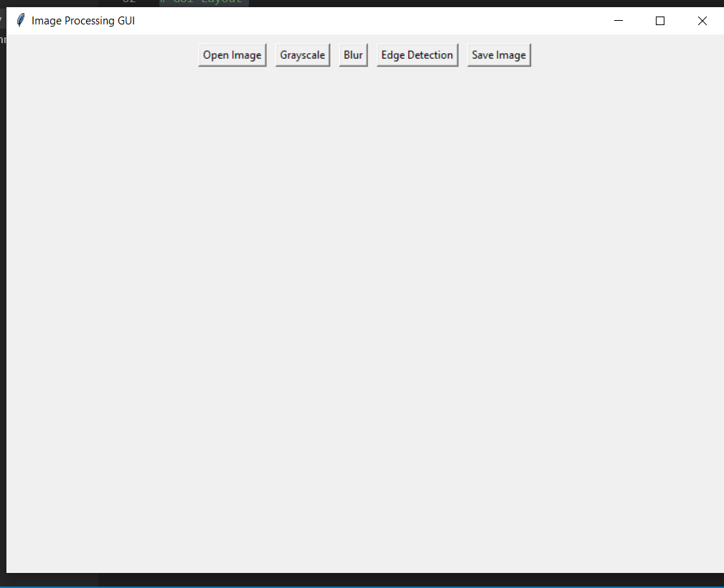
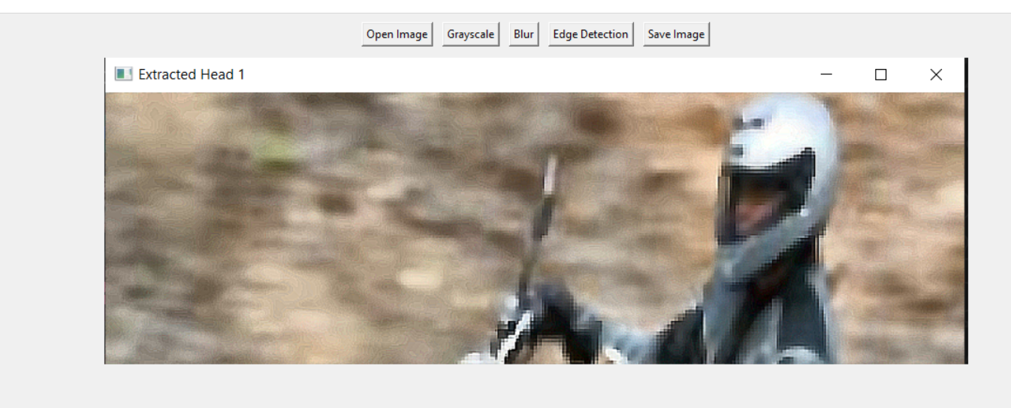
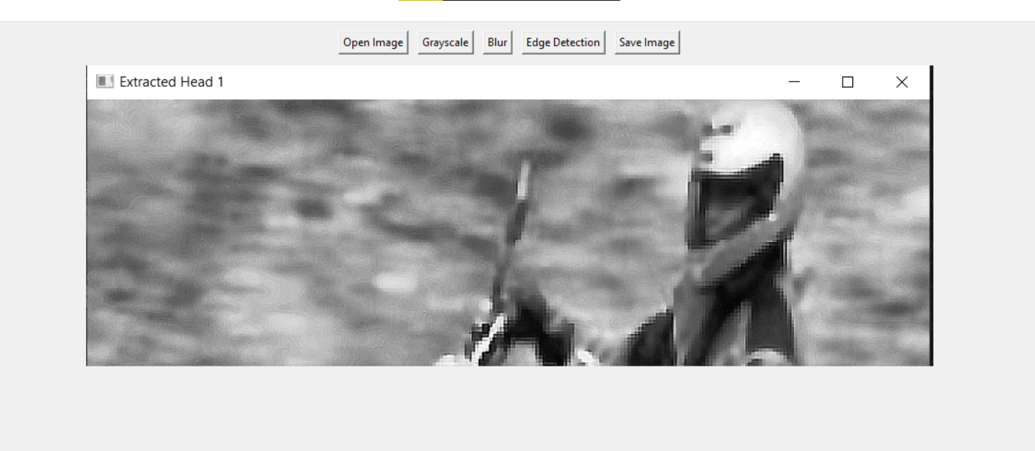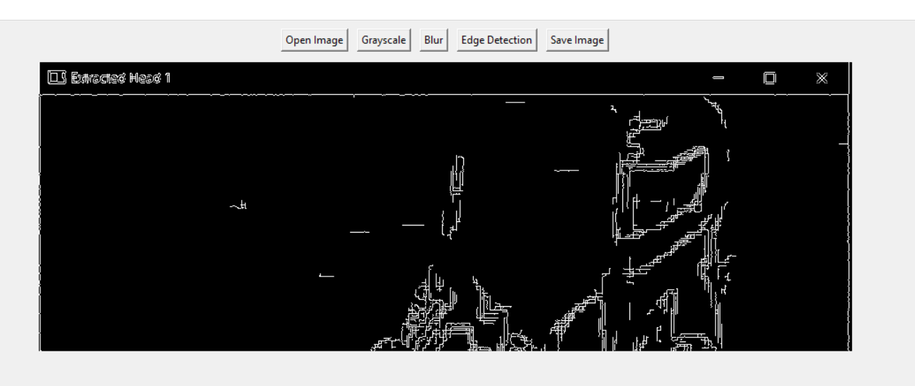

LAB TASK :
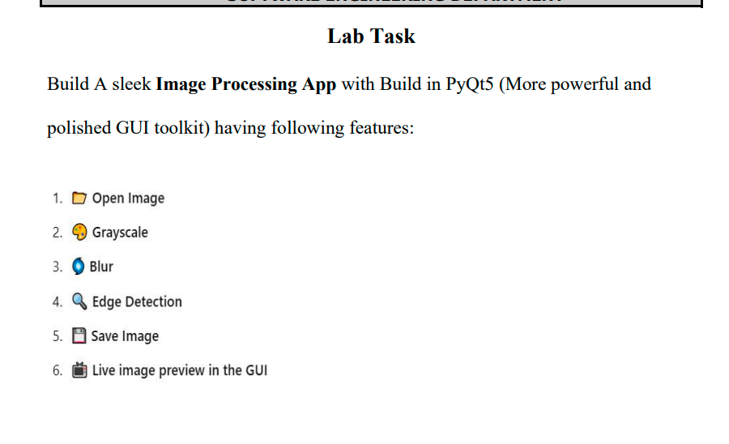
PYTHON CODE :
import sys
import cv2
import numpy as np
from PyQt5.QtWidgets import (QApplication, QMainWindow, QPushButton, QVBoxLayout,
QHBoxLayout, QWidget, QLabel, QFileDialog)
from PyQt5.QtGui import QImage, QPixmap
from PyQt5.QtCore import Qt

class ImageProcessorApp(QMainWindow):
def __init__(self):
super().__init__()

self.setWindowTitle("Sleek Image Processing App")
self.setGeometry(100, 100, 900, 700)

# Variables to store images
self.original_image = None
self.processed_image = None

self.initUI()

def initUI(self):
# Main Layout Container
central_widget = QWidget()
self.setCentralWidget(central_widget)
main_layout = QVBoxLayout(central_widget)

# Image Display Area (Live Preview)
self.image_label = QLabel("No Image Loaded")
self.image_label.setAlignment(Qt.AlignCenter)
self.image_label.setStyleSheet("border: 2px dashed #aaa; background-color: #f0f0f0;")
# This ensures the image stays within the UI bounds (Feature 6)
self.image_label.setMinimumSize(400, 400)
main_layout.addWidget(self.image_label)

# Button Layout
btn_layout = QHBoxLayout()

# Creating Buttons
btn_open = QPushButton("📂 Open Image")
btn_gray = QPushButton("🎨 Grayscale")
btn_blur = QPushButton("🌀 Blur")
btn_edge = QPushButton("🔍 Edge Detection")
btn_save = QPushButton("💾 Save Image")

# Connect Buttons to Functions
btn_open.clicked.connect(self.open_image)
btn_gray.clicked.connect(self.to_grayscale)
btn_blur.clicked.connect(self.apply_blur)
btn_edge.clicked.connect(self.edge_detection)
btn_save.clicked.connect(self.save_image)

# Add buttons to layout
for btn in [btn_open, btn_gray, btn_blur, btn_edge, btn_save]:
btn_layout.addWidget(btn)
btn.setHeight = 40

main_layout.addLayout(btn_layout)

def display_image(self, img):
"""Converts OpenCV BGR image to PyQt QPixmap and displays it."""
if img is None:
return

# Convert BGR to RGB
img_rgb = cv2.cvtColor(img, cv2.COLOR_BGR2RGB)

# Get dimensions
height, width, channel = img_rgb.shape
bytes_per_line = 3 * width

# Create QImage and then QPixmap
q_img = QImage(img_rgb.data, width, height, bytes_per_line, QImage.Format_RGB888)
pixmap = QPixmap.fromImage(q_img)

# Scale pixmap to fit label while maintaining aspect ratio
scaled_pixmap = pixmap.scaled(self.image_label.width(), self.image_label.height(),
Qt.KeepAspectRatio, Qt.SmoothTransformation)

self.image_label.setPixmap(scaled_pixmap)

def open_image(self):
file_path, _ = QFileDialog.getOpenFileName(self, "Open Image", "", "Image Files (*.png *.jpg *.jpeg *.bmp)")
if file_path:
self.original_image = cv2.imread(file_path)
self.processed_image = self.original_image.copy()
self.display_image(self.processed_image)

def to_grayscale(self):
if self.original_image is not None:
gray = cv2.cvtColor(self.original_image, cv2.COLOR_BGR2GRAY)
# Convert back to 3-channel BGR so display logic remains consistent
self.processed_image = cv2.cvtColor(gray, cv2.COLOR_GRAY2BGR)
self.display_image(self.processed_image)

def apply_blur(self):
if self.original_image is not None:
self.processed_image = cv2.GaussianBlur(self.original_image, (15, 15), 0)
self.display_image(self.processed_image)

def edge_detection(self):
if self.original_image is not None:
gray = cv2.cvtColor(self.original_image, cv2.COLOR_BGR2GRAY)
edges = cv2.Canny(gray, 100, 200)
self.processed_image = cv2.cvtColor(edges, cv2.COLOR_GRAY2BGR)
self.display_image(self.processed_image)

def save_image(self):
if self.processed_image is not None:
file_path, _ = QFileDialog.getSaveFileName(self, "Save Image", "", "PNG (*.png);;JPEG (*.jpg)")
if file_path:
cv2.imwrite(file_path, self.processed_image)

if __name__ == "__main__":
app = QApplication(sys.argv)
window = ImageProcessorApp()
window.show()
sys.exit(app.exec_())
OUTPUT :
